Document A: Johnson, Damarius. “International Networks of the American Civil Rights Struggle,” Picturing Black History – The Ohio State University. (Photo by Bettmann Collection/ Getty Images) - https://www.picturingblackhistory.org/international-networks
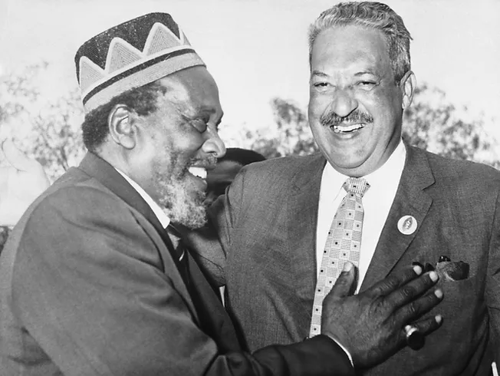
Document B: Johnson, Damarius. “International Networks of the American Civil Rights Struggle,” Picturing Black History – The Ohio State University. (Photo by Pictorial Parade/ Getty Images) - https://www.picturingblackhistory.org/international-networks
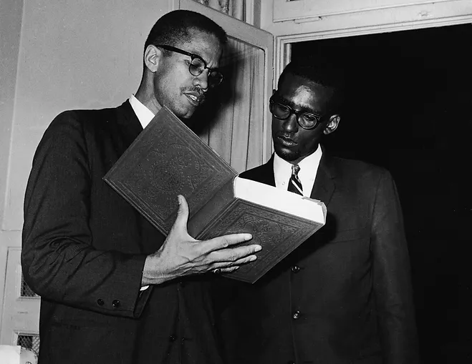
Document C: Johnson, Damarius. “International Networks of the American Civil Rights Struggle,” Picturing Black History – The Ohio State University. (Photo by Rapho Guillemette/Archive Photos/Getty Images) https://www.picturingblackhistory.org/international-networks
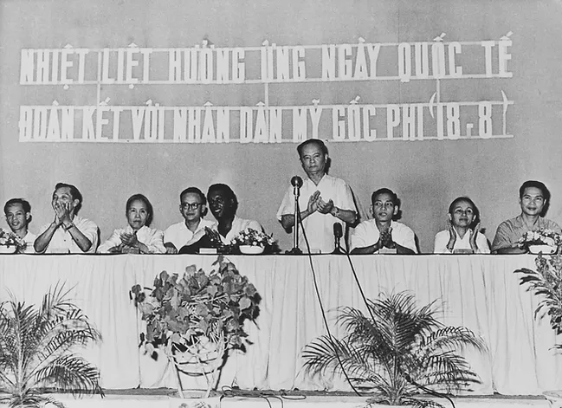

Document D: Paxton, Sarah. “Top Ten Origins: Controversial SCOTUS Nominees,” Origins – The Ohio State University. 2018. https://origins.osu.edu/connecting-history/kavanaugh-blasey-ford-thomas-garland-marshall-controversial-scotus-nominees

6. Justice Thurgood Marshall (1967)

Justice Thurgood Marshall was a renowned civil rights attorney who famously argued Brown v. Board of Education (1954). A clear supporter of the Civil Rights Movement, Marshall’s nomination to both the 2nd Circuit (1961) and SCOTUS (1967) elicited criticisms that he was “too radical” and a “judicial activist.” These critiques served as thinly veiled racial disapproval of the first African American nominee to the Court.

Segregationists like Senators Strom Thurmond (R-SC) and James Eastland (D-MS) attempted to thwart confirmation. Thurmond used his hearing time to interrogate Marshall’s knowledge of obscure doctrines in an attempt to rattle him while Eastland asked if he was “prejudiced against white people in the South.” Despite this opposition, Marshall proved President Lyndon B. Johnson’s assertion that his nomination “was the right thing to do, the right time to do it, the right man and the right place.” He was confirmed 69-11 with 20 abstentions.

Document E: Everett. “The Year of Africa,” Origins – The Ohio State University. 2020. - https://origins.osu.edu/article/year-of-africa-1960-rumba-pan-africanism-Kariba

Independence meant so much more than hoisting a flag. It was the culmination of immense struggle that emerged in the midst of a growing sense African nationalism, global racial solidarity, and multilateral partnerships.

As we look back on the Year of Africa, we should focus on the connections being forged, questioned, reimagined, and molded among African nations and their international partners, in part through conferences.

Conferences among African leaders convened in Tunis, Accra, Conakry, Addis Ababa, and Léopoldville in 1960 alone. They built on earlier multilateral, Third World meetings such as the Bandung Conference (April 18–24, 1955). Also known as the Asian-African Conference, it included 29 countries and represented 1.5 billion people, or 54% of the world population at the time. Its goals were to oppose colonialism and neocolonialism in all its forms.

Similarly, the All-African Peoples’ Conference (AAPC), created in 1958, hosted meetings in December 1958, January 1960, and March 1961. Its objectives were to achieve independence for all colonies, to strengthen already independent states, and to resist neocolonialism.

Another multilateral partnership among African states was the Organisation of African Unity (OAU), which was established on May 25, 1963, in Addis Ababa. This intergovernmental organization originally consisted of 32 signed members and had similar goals to those of the AAPC.

The OAU sought to encourage political and economic cooperation and integration among African states and to free the African continent from colonial and neocolonial control. Although considered ineffective because of policies of non-interference and an inability to enforce decisions without an official armed force, the OAU remains an important component of African independence stories. It eventually became the African Union (AU) officially in July 2002 and now boasts 55 member states.

Document F: Malcolm X. “Speech to the OAU,” Organization of Pan African Unity. 1964. - http://oopau.org/2.html

The Organization of Afro-American Unity has sent me to attend this historic African Summit Conference as an observer to represent the interests of 22 million African-Americans whose human rights are being violated daily by the racism of American imperialists.

The Organization of Afro-American Unity has been formed by a cross section of America's African-American community, and is patterned after the letter and spirit of the Organization of African Unity.

Just as the Organization of African Unity has called upon all African leaders to submerge their differences and unite on common objectives for the common good of all Africans, in America the Organization of Afro-American Unity has called upon Afro-American leaders to submerge their differences and find areas of agreement wherein we can work in unity for the good of the entire 22 million African Americans.

Since the 22 million of us were originally Africans, who are now in America, not by choice but only by a cruel accident in our history, we strongly believe that African problems are our problems and our problems are African problems.

We also believe that as heads of the independent African states you are the shepherds of all African peoples everywhere, whether they are still at home here on the mother continent or have been scattered abroad.

Some African leaders at this conference have implied that they have enough problems here on the mother continent without adding the Afro-American problem.

With all due respect to your esteemed positions, I must remind all of you that the Good Shepherd will leave ninety-nine sheep who are safe at home to go to the aid of the one who is lost and has fallen into the clutches of the imperialist wolf.

We in America are your long-lost brothers and sisters, and I am here only to remind you that our problems are your problems. As the African-Americans "awaken" today, we find ourselves in a strange land that has rejected us, and, like the prodigal son, we are turning to our elder brothers for help. We pray our pleas will not fall upon deaf ears.

We were taken forcibly in chains from this mother continent and have now spent over three hundred years in America, suffering the most inhuman forms of physical and psychological tortures imaginable.

During the past ten years the entire world has witnessed our men, women, and children being attacked and bitten by vicious police dogs, brutally beaten by police clubs, and washed down the sewers by high-pressure water hoses that would rip the clothes from our bodies and the flesh from our limbs.

And all of these inhuman atrocities have been inflicted upon us by the American governmental authorities, the police themselves, for no reason other than that we seek the recognition and respect granted other human beings in America.

The American Government is either unable or unwilling to protect the lives and property of your 22 million African-American brothers and sisters. We stand defenseless, at the mercy of American racists who murder us at will for no reason other than we are black and of African descent….
Document G: Beverton, Alys. “Organization of African Unity (1963-2002),” BlackPast. 2009. - https://www.blackpast.org/global-african-history/organization-african-unity-1963-2002/

The Organization of African Unity (OAU, 1963-2002) was an alliance of independent African nations working to enhance cooperation between the newly decolonized African governments. The alliance had its basis in the Pan-Africanist philosophy encouraging the unity of all peoples of African ancestry, but it also was inspired by ongoing independence struggles as various African nations freed themselves from European colonial rule in the early 1960s.

On May 25, 1963, Ethiopian Emperor Haile Selassie invited the heads of the 32 independent African nations at the time to convene at his country’s capital, Addis Ababa. The result of this conference was the formation of the OAU, which would grow in membership to include 54 of the 55 African states as members. Morocco was the only state to decline membership.

The OAU’s basic principles included promotion of solidarity among African states, improved quality of life for Africans, a promise to defend the sovereignty of African states, and eradication of colonialism in all its forms. The OAU hoped to achieve these goals through cooperation and peaceful negotiation between its members.

The OAU established various working groups, including the Commission of Mediation, Conciliation and Arbitration, which was designed to aid with the peaceful settlement of disputes between members. The OAU also helped to finance independence movements in those nations still under European rule, thus playing an instrumental role in independence for such states as Zimbabwe in 1980. The OAU further was committed to battling apartheid and white minority rule in states such as South Africa, which joined the organization in 1994.

Ideological differences between the member states often made agreement on a single course of action difficult. The absence of an armed force similar to the United Nations’ peacekeeping contingents left the organization with no means to enforce its edicts. And its unwillingness to intervene in the internal affairs of member nations often meant it would not confront brutal dictatorships such as Idi Amin‘s regime in Uganda or domestic crises such as the Rwandan Genocide, prompting some observers to criticize the OAU as a forum for rhetoric rather than action.

Recognizing many of these shortcomings, the OAU in September 1999 issued the Sirte Declaration, calling for a new body to take its place. On July 9, 2002, this proposal was fulfilled with the creation of the African Union (2002- ), which continues to this day to uphold many of the founding principles of the OAU.

Document H: History.com Editors. “Stokely Carmichael,” History.com. 2019. - https://www.history.com/topics/black-history/stokely-carmichael

Stokely Carmichael was a U.S. civil-rights activist who in the 1960s originated the Black nationalism rallying slogan, “Black power.” Born in Trinidad, he immigrated to New York City in 1952. While attending Howard University, he joined the Student Nonviolent Coordinating Committee and was jailed for his work with Freedom Riders. He moved away from MLK Jr’s nonviolence approach to self-defense.

The phrase “Black power” quickly caught on as the rallying cry of a younger, more radical generation of civil rights activists. The term also resonated internationally, becoming a slogan of resistance to European imperialism in Africa. In his 1968 book, Black Power: The Politics of Liberation, Carmichael explained the meaning of Black power: ”It is a call for Black people in this country to unite, to recognize their heritage, to build a sense of community. It is a call for Black people to define their own goals, to lead their own organizations.”

Black power also represented Carmichael’s break with King’s doctrine of nonviolence and its end goal of racial integration. Instead, he associated the term with the doctrine of Black separatism, articulated most prominently by Malcolm X. “When you talk of Black power, you talk of building a movement that will smash everything Western civilization has created,” Carmichael said in one speech. Unsurprisingly, the turn to Black power proved controversial, evoking fear in many white Americans, even those previously sympathetic to the civil rights movement, and exacerbating fissures within the movement itself between older proponents of nonviolence and younger advocates of separatism. Martin Luther King called Black power “an unfortunate choice of words.”

In 1967, Carmichael took a transformative journey, traveling outside the United States to visit with revolutionary leaders in Cuba, North Vietnam, China and Guinea. Upon his return to the United States, he left SNCC and became Prime Minister of the more radical Black Panthers. He spent the next two years speaking around the country and writing essays on Black nationalism, Black separatism and, increasingly, pan-Africanism, which ultimately became Carmichael’s life cause. In 1969, Carmichael quit the Black Panthers and left the United States to take up permanent residence in Conakry, Guinea, where he dedicated his life to the cause of pan-African unity. “America does not belong to the Blacks,” he said, explaining his departure from the country. Carmichael changed his name to Kwame Toure to honor both the President of Ghana, Kwame Nkrumah, and the President of Guinea, Sekou Toure.

In 1968, Carmichael married Miriam Makeba, a South African singer. After they divorced, he later married a Guinean doctor named Marlyatou Barry. Although he made frequent trips back to the United States to advocate pan-Africanism as the only true path to liberation for Black people worldwide, Carmichael maintained permanent residence in Guinea for the rest of his life. Carmichael was diagnosed with prostate cancer in 1985, and although it is unclear precisely what he meant, he said publicly that his cancer “was given to me by forces of American imperialism and others who conspired with them.” He died on November 15, 1998, at the age of 57.

Document I: Kobo, Ousman Murzik. “A New World Order? Africa and China,” Origins – The Ohio State University. 2013. - https://origins.osu.edu/article/new-world-order-africa-and-china

The Bandung Conference in Indonesia in 1955, attended by most of the developing world, marked the starting point. Many attendees were young African nationalists whose core agenda was eradicating colonialism and forging a common front to safeguard the sovereignty of emerging nations against Cold War politics.

The Bandung Conference was followed by a series of conferences that culminated in the formation of the Non-Aligned Movement in 1961. By this time, most of Africa had gained independence from European colonial rule and had joined the movement.

As a permanent member of the United Nations Security Council and the largest member of the non-aligned group, China emerged as the de facto leader of the developing world. Although a communist nation, China declared both the Soviet Union and the U.S.-led Western powers neo-colonialists. China presented itself to the developing world as an alternative ideological partner that shared the experience of colonial domination and exploitation.

A major refrain in China’s foreign policy statements even today is reference to the historical experience of humiliation by the West and Imperial Japan. Indeed, at the Bandung Conference, China declared its intent to help liberation fighters throughout the world, and this became the hallmark of China’s Africa policy from the 1950s to the end of the Cold War in 1990.

During this period, China offered military intelligence, weapons, and training to freedom fighters in Algeria, Angola, Zimbabwe, Mozambique, Guinea Bissau, and Namibia. Even the African National Congress and the Pan African Congress of South Africa received some support in their struggles against apartheid South Africa. This policy appealed to many young African nationalists, including Kwame Nkrumah of Ghana, Jamal Abdul Nasser of Egypt, Julius Nyerere of Tanzania, and King Hasan of Morocco.

