Sources for Major Players (as they appear in Stations activity)

Station One/Document A: Emrich, R. (2011, February 23). Minoso's Perseverance Paved his Way. MiLB.com. Retrieved February 27, 2022, from https://www.milb.com/news/gcs-16600436
“Playing in a tumultuous time, long before the civil rights movement of the 1960's, Minoso faced discrimination mainly from other players.

"The discrimination was definitely greater in the big leagues," he said. "In the Negro Leagues, it was blacks against blacks -- there were less differences between us. When I played in the big leagues and started playing amongst white people, it was a lot tougher. The coaches were never discriminatory, but with the players it was different.”

Station One/Document B: Smith, R. (2016, February 4). Minnie Minoso. Ninety Feet of Perfection. Retrieved February 27, 2022, from https://90feetofperfection.com/2015/04/03/minnie-minoso/
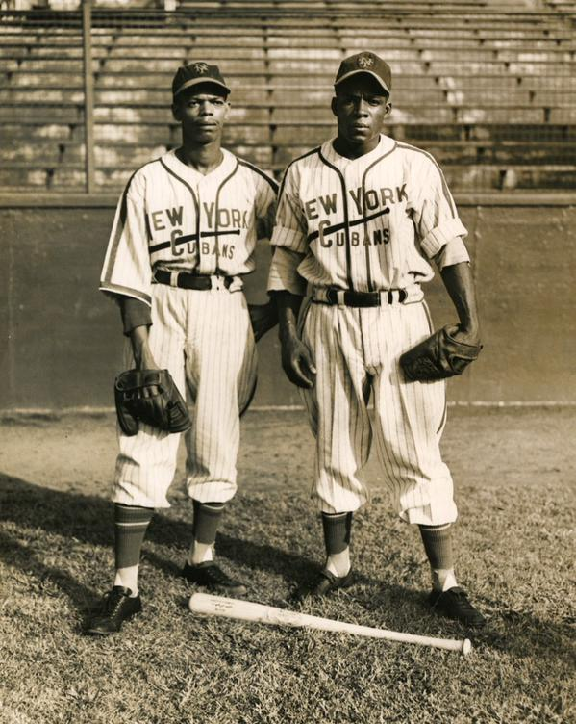

Station 1/Document C: Burgos, A. (2015, March 1). Minnie Minoso was victim of Unfair Hall of Fame Election Rules. Sporting News. Retrieved February 27, 2022, from https://www.sportingnews.com/us/mlb/news/minnie-minoso-dead-dies-hall-of-fame-obituary-white-sox-indians-election/6k7o72rs966f1utvju92wsadk
“The Hall of Fame has long enforced its rule that individuals could only be considered for the Hall of Fame as either a player in the major leagues or in Negro Leagues, an umpire or team/league executive. This has meant that Miñoso would either be considered as a Negro Leaguer or as a major leaguer, but voters could not take into consideration what he accomplished in the other circuit in casting one’s vote.

Instead of taking into account the entire arc of Miñoso’s baseball career in the United States from the Negro Leagues to the majors, Hall of Fame voters are instructed they cannot. I encountered this first-hand as part of the 2006 Special Negro League Election Committee in which Miñoso and Buck O’Neil were the only living candidates on the ballot. We received the per-usual instructions that we could not weigh Miñoso’s big league accomplishments into our deliberations.”

Station 2/Document D: Archive. (2018, April 12). Nat 'king' Cole attacked on stage – archive, 12 April 1956. The Guardian. Retrieved February 27, 2022, from https://www.theguardian.com/world/2018/apr/12/nat-king-cole-attacked-on-stage-archive-1956
“BIRMINGHAM (ALA.) APRIL 11.
Nat “King” Cole, the Negro entertainer, to-day cancelled three appearances in the Southern United States and left for Chicago to rest after being attacked by white men while he was singing with Ted Heath’s band here last night. Mr. Cole received a slight back injury during the scuffle. To-day six men were formally charged with assault with intent to murder him, but later the charge against four of them was changed to conspiracy to commit a misdemeanour.
Later, police reported more than a hundred white men had planned to attack Cole and overpower Heath’s band. They said the affair had been planned four days before it took place. A total of 150 men from the Birmingham area and near-by towns were to have arrived at the auditorium, but the mob failed to show up.
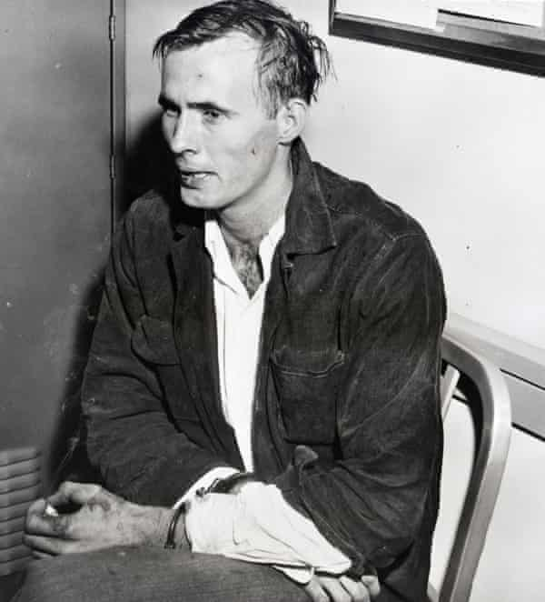
Willie Richard Vinson, 23, of Anniston, AL, sits in handcuffs after he and five others were taken into custody following an attack on entertainer Nat “King” Cole. Photograph: Bettmann/Bettmann Archive
Mr Cole was singing when men from the audience clambered over the footlights and rushed at him. One grabbed his knees and brought him to the floor. Police ran on to the stage and seized three of the assailants. The three others were arrested later.
Mr Cole, who was appearing before an all-white audience, has been active in the fight for equal rights for Negroes. One of the men arrested is a member of the board of directors of the local White Citizens’ Council, which supports segregation. Police said they came in a car in which were found several rifles, coshes, and brass knuckles. The council is waging a campaign to rid Alabama of “rock and roll” music which it calls immoral, claiming that the music is a scheme by the National Association for the Advancement of Coloured People of which Mr. Cole is a member, to bring white youths in favour of integration of the races in the South.

Station 2/Document E: Owen, J. (2014, May 17). The Story of Nat king Cole and his Racist Neighbours. The Independent. Retrieved February 27, 2022, from https://www.independent.co.uk/arts-entertainment/music/news/the-story-of-nat-king-cole-and-his-racist-neighbours-9391316.html
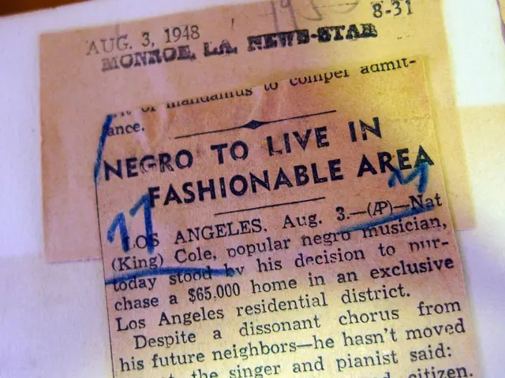

Station 2/Document F: Spigner, C. (2021, May 20). Nat "king" Cole (1919-1965) •. Nat "King" Cole (1919-1965) •. Retrieved February 27, 2022, from https://www.blackpast.org/african-american-history/cole-nat-king-1919-1965/
Cole’s actions were often controversial within the African American community. Claiming that he had never taken part in civil rights protests, he expressed surprise when he was attacked by white supremacists in Birmingham in 1956. At the same time, however, he contributed to civil rights causes such as the Montgomery Bus Boycott, and he filed lawsuits against northern hotels that refused him service. Still, Cole’s performances for “Jim Crow” audiences disturbed black activists. Thurgood Marshall, then chief legal counsel to the National Association for the Advancement of Colored People (NAACP), reportedly labeled Cole an “Uncle Tom.” The Amsterdam News saw Cole as an “insult to his race.” Such accusations were obvious overstatements, but—recognizing their concerns—Cole finally joined other entertainers in refusing to perform before segregated audiences. In 1956 he performed at the Republican National Convention, and in 1960 at the Democratic National Convention

Station 3/Document G: Minnie Minoso Minor, Winter, Mexican & Independent Leagues Statistics & History. Baseball. (n.d.). Retrieved February 27, 2022, from https://www.baseball-reference.com/register/player.fcgi?id=minoso001sat
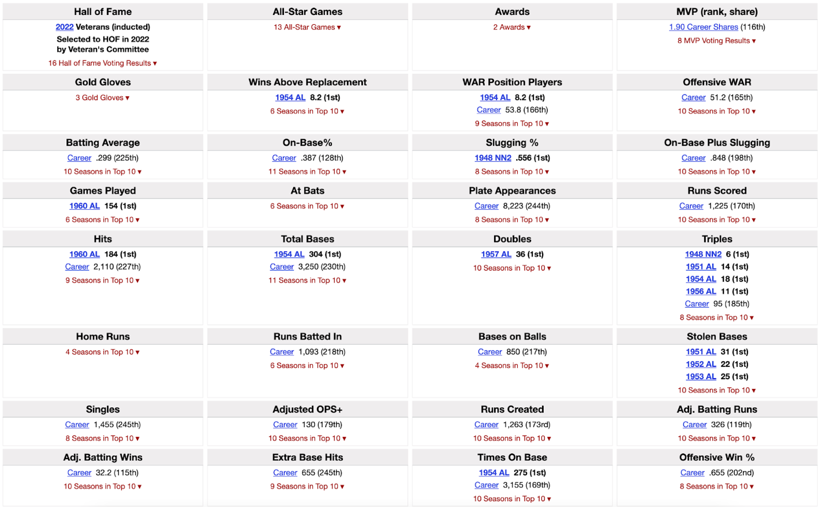
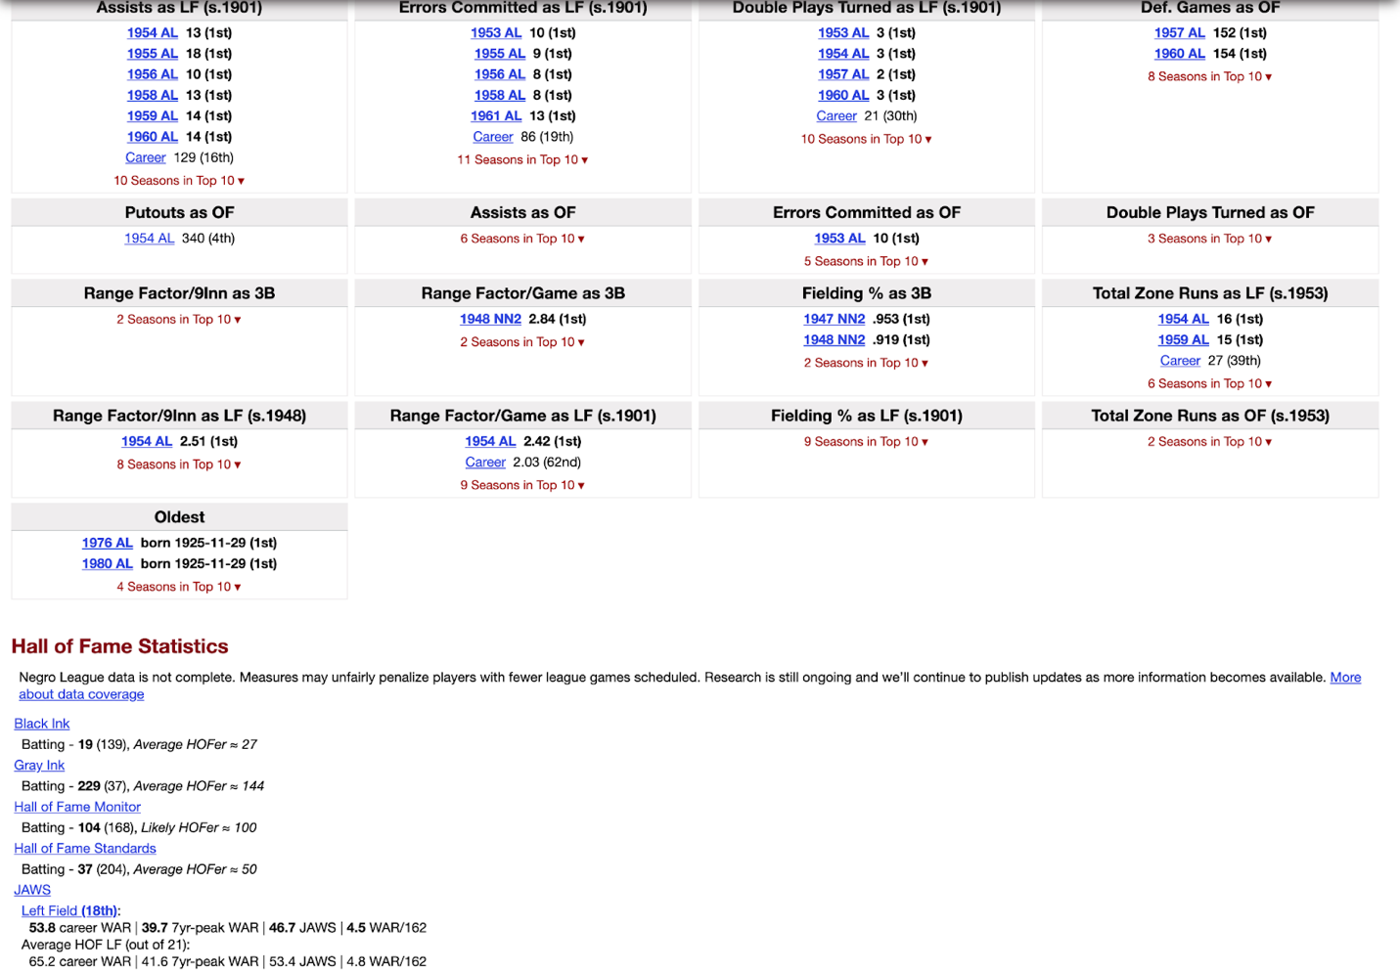

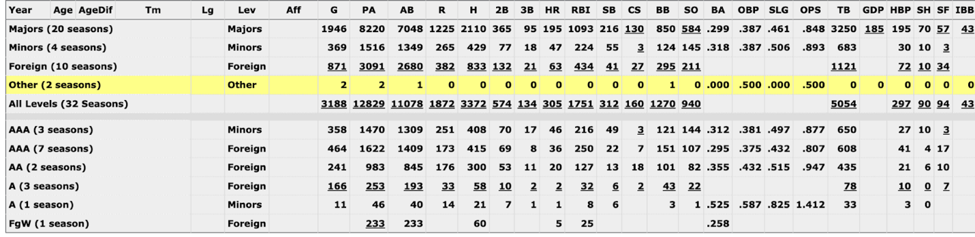

Station 3/Document H: Chupp, J. (n.d.). Hall of stats. Hall of Stats: An alternate Hall of Fame populated by a mathematical formula. Retrieved February 27, 2022, from http://hallofstats.com/player/minosmi01

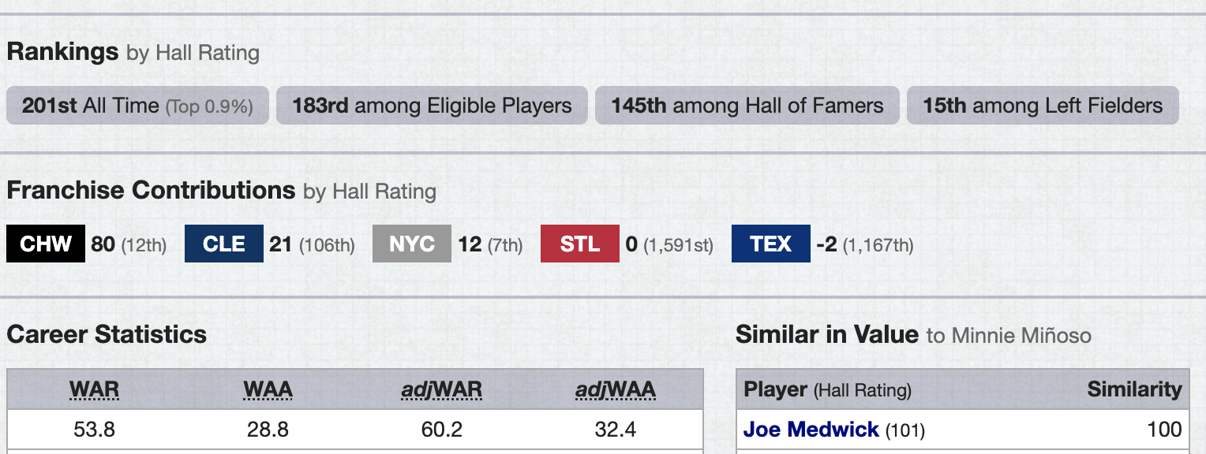

Station 3/Document I: Burgos, A. (2015, March 1). Minnie Minoso was victim of Unfair Hall of Fame Election Rules. Sporting News. Retrieved February 27, 2022, from https://www.sportingnews.com/us/mlb/news/minnie-minoso-dead-dies-hall-of-fame-obituary-white-sox-indians-election/6k7o72rs966f1utvju92wsadk

“Miñoso’s path was in fact a bit different than Robinson and Doby. As a black Latino, he encountered what Clemente himself stated were “two strikes” while in the United States: one for being black, another for being Latino. Moreover, as a foreign-born black man, Miñoso lacked a familiarity with US racial mores and practices that Robinson and Doby had as they embarked on their big league careers. None of this deterred the man who would become Minnie in his adopted hometown of Chicago.
Miñoso won the hearts of Chicago White Sox’s faithful from his very first appearance, homering in his first at-bat against the Yankees at Comiskey Park. His rookie campaign would see him enjoy the highs of being named an American League All-Star and winning the Sporting News Rookie of the Year honor. It would also expose him to the inconsistency of the U.S. sporting press when baseball writers voted Yankees third baseman Gil McDougal its Rookie of the Year even while Miñoso would garner more Most Valuable Player votes.”

Station 4/Document J: Johnson, D. (2020, February 10). "The jackie robinson of television": The nat king cole show. Night Lights - Indiana Public Media. Retrieved February 27, 2022, from https://indianapublicmedia.org/nightlights/nat-king-cole-show.php
“The same grace and genuine quality that made Cole such an accessible singer made him an effective television host as well. Though the show continued in vain to try to find national sponsors, it also continued to enjoy a memorable run of guests, as well as good ratings, and in July 1957 NBC expanded it to 30 minutes and moved it to Tuesday evenings, albeit at a later time, 10 p.m. Newsweek reported that the show was being carried by 77 stations, "nearly half of them below the Mason-Dixon line."…
Interacting with jazz musicians was a breeze for Cole; white women artists presented a more challenging context… When stars such as Peggy Lee appeared on "The Nat King Cole Show," Cole retained his natural ease, but initially care was taken to keep a small degree of physical separation in any scenes that brought the host and his guest together. As the show went on, however, Cole and his producer Bob Henry became more determined to showcase its element of integration. These efforts reached their zenith on the December 3, 1957 broadcast, in which Cole and guest star Betty Hutton did a light comedy sketch of singing each other‘s hits, then joined forces to sing a song they‘d both recorded, "Orange Colored Sky." Not only that, they danced together—an African-American man and a white woman, an extraordinary event for national television in 1957. "We proved that a Negro star could play host to whites, including women, and we proved it in such good taste that no one was offended," Cole later said”

Station 4/Document K: Nat king Cole. Spotify. (n.d.). Retrieved February 27, 2022, from https://open.spotify.com/artist/7v4imS0moSyGdXyLgVTIV7
