Sources Packet

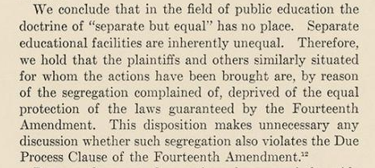
Document A: The landmark Supreme Court decision in Brown v. Board of Education of Topeka, which states that the doctrine of "separate but equal" has no place in public education. (Records of the Supreme Court of the United States, RG 267)

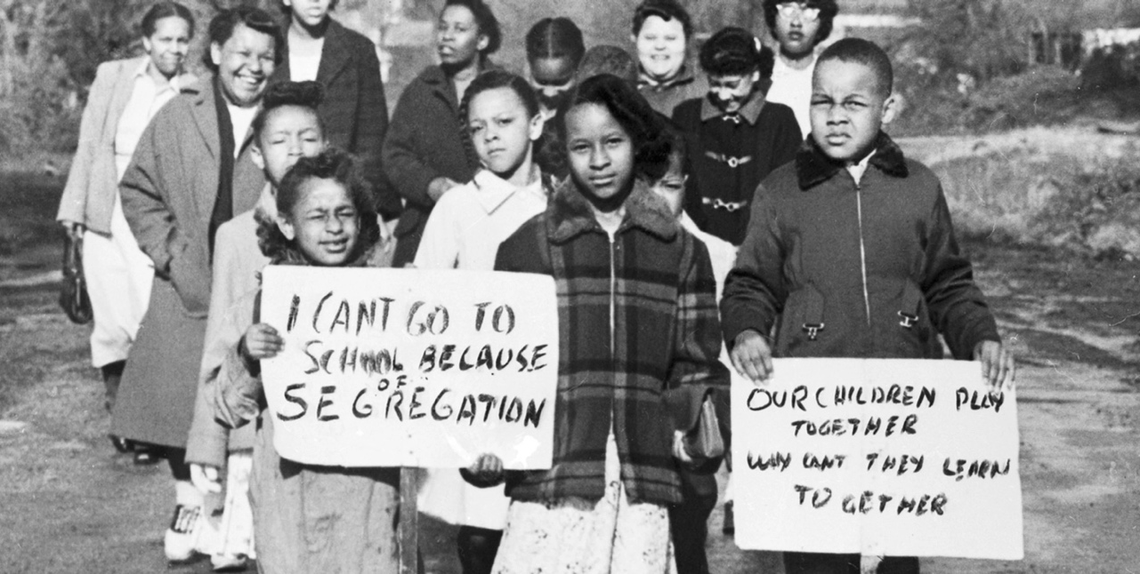
Document B: African American mothers and their children fought for school integration in 1954, in Hillsboro, Ohio. (The Lincoln School Story, Torrice Media) One child is holding a sign that reads “I can’t go to school because of segregation” and another has a sign that says “Our children play together, Why can’t they learn together?”
Document C: Excerpt from “Marching Mothers” by Jessica Viñas-Nelson, Picturing Black History

“[Ohio’s] first public schools only allowed funding for ‘white youths.’ In 1848, Black Ohioans won the right to be taxed for the education of Black children. After another hard fight, the state repealed a provision allowing segregation in 1887. Nevertheless, many Ohio schools remained segregated.

In 1954, all of Hillsboro’s seventy Black elementary students attended Lincoln School. Many had to walk past the all-white schools to reach Lincoln, the all-Black school. Hillsboro’s schools, segregated since at least 1869, formalized segregation in 1939. By 1954, the fight for integrated education was over a century old and school segregation had been illegal in the state for 70 years.

The summer after Brown, Imogene Curtis, Gertrude Clemons, and several other mothers started a petition demanding integration of Lincoln’s students and teachers into Washington and Webster. 50 Black students accompanied by their parents presented themselves at Washington and Webster on the first day of school. Segregation seemed like it might come to an anticlimactic end as they were enrolled and assigned classrooms.

Within days, the school board redrew district lines. The resulting map was drawn so that only a handful of Black children were assigned to Washington and Webster. Lincoln remained all-Black. White students, a board member later told the court, would be insulted if assigned to Lincoln.

Unwilling to accept this charade, the mothers began marching their children to Washington and Webster each day only to be rebuffed. Every day meant another morning march for some 20 mothers and 40 children. Throughout the 1954-55 and 1955-56 school years they marched every day without fail.

Brown receives a lot of praise for ending school segregation. But the ruling didn’t make it a reality. Black students and parents’ actions, sacrifices, persistence, and continuing fight today gave Brown meaning. The burden of enforcement was borne on the backs (and marching feet) of Hillsboro students and parents in what became the first northern test case of the Brown decision.”

Document D: Graph from “Schools are still segregated, and black children are paying a price” by Emma García, Economic Policy Institute

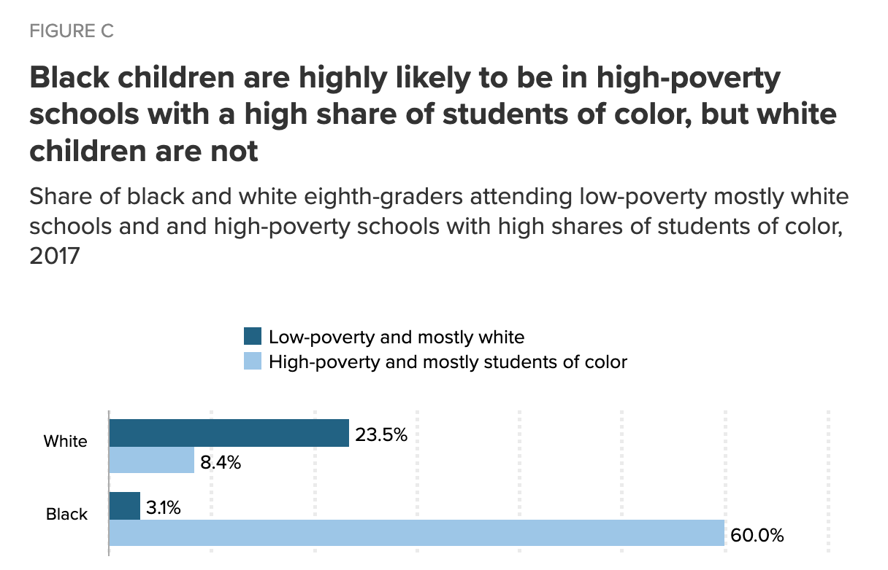

Document E: Excerpt on Penick v. Columbus Board of Education, 1977, from Ohio History Central

The federal court case, Penick v. Columbus Board of Education, led to the desegregation of Columbus, Ohio's public schools.
Circuit Court Judge Robert Duncan ruled in Penick v. Columbus Board of Education that schools in Columbus, Ohio were segregated and that the Columbus Board of Education knowingly kept white and African American students apart from each other by creating school boundaries that sent African American students to predominantly African American schools and white students to predominantly white schools. Duncan cited evidence that this policy had existed since at least 1909. The judge made his ruling on March 8, 1977.
As a result of this ruling, the Columbus Board of Education began a program of school busing to create a desegregated school district. The school system bused some white students to traditionally African American schools and bused some African American students to historically white schools. Within two years of the judge's decision, approximately one-third of Columbus Public School students rode buses to school.

Document F: Excerpt from “After 50-Year Legal Struggle, Mississippi School District Ordered to Desegregate,” May 17th, 2016, by Camila Domonoske, NPR

The Brown v. Board of Education decision was historic — but it's not history yet.
Just this week, a federal judge ordered a Mississippi school district to desegregate its schools.
The case on which the judge was ruling was originally brought during the summer of 1965. The first named plaintiff, "Diane Cowan, minor," was a fourth grader at the time. Now she’s a 57-year-old clerk with the U.S. Postal Service.
The legal saga that bears her name continues because, for 50 years, the Cleveland, Miss., school district has failed to integrate.
The town of 12,000 people — like many, many towns and cities in America — is racially segregated. A railroad track runs through town. Black people live on the east side of the tracks; white people live on the west side.
"In a school district where approximately 67 percent of the students are black and 30 percent of the students are white, half of Cleveland's schools — the schools on the east side of the railroad tracks — are all black or virtually all black," the federal government wrote. The other schools were disproportionately white.
It is finally time for the nuclear option: merging both high schools into a single school with around 1,000 students, and similarly combining middle schools.
Some residents thought that would be too big and that the town couldn't afford new buildings.
They also argued that forcing integration by merging would cause white families to turn to private schools, causing a drop in enrollment.
No dice, said the judge: The fear of white flight doesn't override students' constitutional right to an integrated education.

