Opener and Exit Ticket Worksheet

Directions: Use the space below to write your reflection on the opener for class today.

____________________________________________________________________________________________________________________________________________________________________________________________________________________________________________________________________________________________________________________________________________________________________________________________________________________________________________________________________________________

Vocabulary from Opener:

Mass incarceration - the imprisonment of a large proportion of a population.

Eradicate - destroy completely; put an end to.

Resonate - evoke or suggest images, memories, and emotions.

Directions: Use the space below to write a poem. Utilize the structure of Claude McKay’s, “If We Must Die”, the information displayed and discussed in the station’s activity, and your own connections to create a poem that responds to how the circumstances of Gilligan’s case are reflected in society today.

“If We Must Die” is written in the format abab cdcd efef gg
You will write a poem that is abab cdcd ee (10 lines)

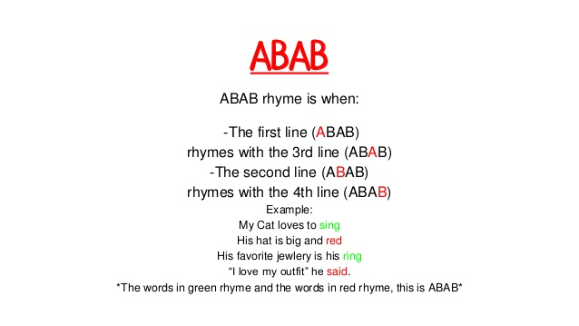

Line 1: ___________________________________________
Line 2: ___________________________________________
Line 3: ___________________________________________
Line 4: ___________________________________________

Line 5: ___________________________________________
Line 6: ___________________________________________
Line 7: ___________________________________________
Line 8: ___________________________________________

Line 9: ___________________________________________
Line 10: __________________________________________

