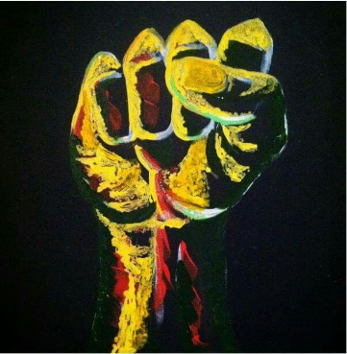
Historical Circumstances of Policy Brutality in the U.S. – Stations Activity *
Station 1: Documents A and B *
- The poem “If We Must Die” was written in 1919 during the Red Summer, when mobs of white people were attacking black communities. Why do you think the words of this poem resonated with protesters against police brutality in 1964?

- What lines in the poem stick out to you the most? What do you think Claude McKay was trying to convey?

In groups of 4-5, you will complete a stations activity. In this activity, you will read and analyze a series of sources relating to police brutality. This includes newspaper excerpts, artwork, and photographs from both the sixties and the present. Each station will have 2-3 documents to look at that will be labeled “Document A, B, C…”. You will answer the corresponding questions below with your group members.

Station 2: Documents C and D *
- The 1964 newspaper article stated,” the head of the local N.A.A.C.P. chapter, called the grand jury action ‘about what we could expect’. ‘These grand juries have a long record of exoneration of police officers accused of brutality against Negroes,’ he said.” What does this statement tell you about the experiences of Black people in America in both the past and the present?

- What do you notice about the people in this photograph? Who is depicted, what are their demographics?

Station 3: Documents E and F *
- One of the opinions from the newspaper article described life as a game of catch up with white people and POC at very different places in this game. What does she mean by this? How is her comparison supported by stories like that of Gilligan and Powell?

- Another writer in this newspaper article shared, “I thought for sure that George Zimmerman would be found guilty — how could he not? I was so naïve.” How is this outlook on the outcome of a trial in which a young Black person was killed different from that of the NAACP official from Document C?

Station 4: Documents G, H, I *
- Documents G and H are artistic responses to the murder of George Floyd in 2020 by a police officer. What emotions do these art pieces evoke? What do you think they represent for the Black community?

- Historically, music, poetry, art, and other forms of creative expression have been used in response to the continuation of police brutality in America and as a form of activism. Why do you think these mediums are used? How do they help the Black community?

- John Lewis is pictured at age 25 in 1965 being beaten by state troopers during a voting rights march in Selma. A portrait of him in his later life with his words is included as well. How do his words capture the experiences and the outlook of Black people of the past, present, and future in America?

