Carter G Woodson Jigsaw Worksheet

Directions:
Using the next 4 sources, you will learn about Carter G Woodson.

- First, you will be placed in a group of four (you and three of your peers).

- You will then be assigned to read 1 of the following 4 documents. Read your assigned document and take notes on your jigsaw activity sheet.

- Once you have completed the reading and notetaking, you will be instructed to meet with other students who read the same document as you. With your peers, you will discuss your assigned document and become an expert on the information.

Using information from your peers, add information to your notes that you did not previously have.

- Next, after becoming an expert on your assigned document, you will return to your original group of four students. Each student in your group will present their findings and expertise on the document they read. Please ask your peers questions if you have them!

- While listening to your peers share their expertise, take notes on the other 3 jigsaw documents you did not read.

- Ultimate goal – Each student will learn about all 4 jigsaw sources: the source you read AND the 3 other sources your peers presented in small groups.

Directions: In the space provided, take notes on your assigned document. State which document you read here: __________________

Directions: Here, after listening to your peers discuss their assigned document, take notes for each of the 3 documents you did not read.

Directions: Based on the discussions your group participated in, describe how you think Carter G Woodson would want you and other students to learn about Black history.

Think about the components of Black history Woodson thought were so important.

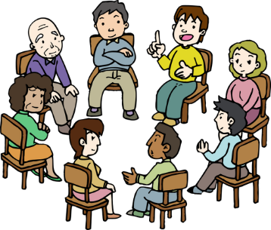
Work together to create this description. Remember, good discussions go beyond just copying information from others.

