Name: ______________

Infrastructure Guided Notes
- Infrastructure
The basic physical and organizational structures and facilities (e.g. ____________, ____________, ______________) needed for the operation of a society or enterprise.

Terms
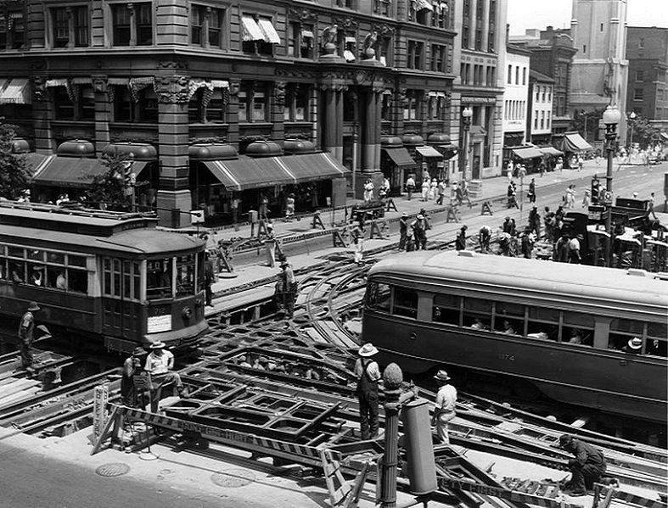
- Capacity: the maximum amount that something can ___________.
- Does the infrastructure’s capacity meet current and future demands?

- Condition: the state of something with regard to its ___________, quality, or working order.
- What is the infrastructure’s existing and near-future physical condition?

- Funding: money provided, especially by an__________ or _____________, for a particular purpose.
- What is the current level of funding from all levels of government for the infrastructure category as compared to the estimated funding need?
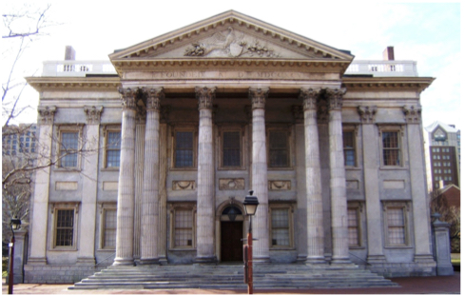
- Future Need: What is the ___________________________ infrastructure? Will future funding prospects address the need?
- Operation: the fact or condition of functioning or being active.
- Maintenance: the process of ______________ or preserving someone or something, or the state of being maintained
  - What is the owners’ ability to operate and maintain the infrastructure properly? Is the infrastructure in compliance with government regulations?

- Public Safety: To what extent is the public’s safety jeopardized by the condition of the infrastructure and what could be the consequences of failure?

- Resilience: the capacity to _____________________ from difficulties; toughness.
- Innovation: make changes in something established, especially by introducing new _____________, _________, or _________________.
  - What new and innovative techniques, materials, technologies, and delivery methods are being implemented to improve the infrastructure?

