Gallery Walk Worksheet
When the teacher says to begin, move with your tablemates to the Gallery Walk artifact listed on your table. Answer the questions on your iPad.
When the teacher calls time, move clockwise to the next artifact. You will have 4 minutes per station!
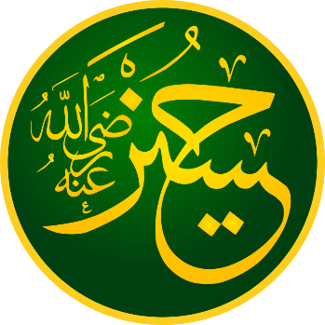
Station 2/6
Which of the Pillars of Islam are also present in Shia’s “Ancillaries of the Faith”?

_________, _________, __________, and _____________

What else is present in this list?

____________, __________ (struggle), and Tawalla and Tabara
Station 1/6
Which of the Five Pillars of Islam are mentioned in this Hadith?

__________, ___________, __________, and ___________

Do these descriptions of “faith”, “Islam”, and “perfection” describe who should be in charge of the Islamic community? Circle your opinion.
Yes/No
Station 3/6
Which branch of Islam is followed in more countries, Shia or Sunni? Circle the answer.

Station 6/6
The painting shows parts of the Battle of Karbala. Do you think that the Sunni-Shia split was the result of a misunderstanding, or a deeper disagreement? Why?

I think that it was a misunderstanding/real disagreement, because…
Station 4/6
This dictionary entry has several meanings for مولى (Mawla). Which of these definitions are opposites?
Slave and _________
Friend and _________
How might this become a problem?
Someone might think that Ali should be a ___________, and others just a friend.

Station 5/6
Who does this hadith say is a Muslim’s “mawla”?

Muhammad’s son-in-law, named __________.

