**Gallery Walk Worksheet**

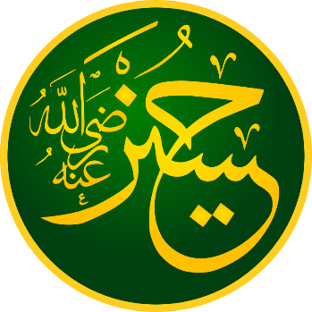

When the teacher says to begin, move with your tablemates to the Gallery Walk artifact listed on your table.

When the teacher calls time, move clockwise to the next artifact. You will have 4 minutes per poster!

**Station 3/6**

Which branch of Islam is followed in more countries, Shia or Sunni?

**Station 2/6**

Which of the Pillars of Islam are also present in Shia’s “Ancillaries of the Faith”?

What else is present in this list?

**Station 1/6**

Which of the Five Pillars of Islam are mentioned in this Hadith?

Do these descriptions of “faith”, “Islam”, and “perfection” describe who should be in charge of the Islamic community?

**Station 6/6**

The painting shows parts of the Battle of Karbala. Do you think that the Sunni-Shia split was the result of a misunderstanding, or a deeper disagreement? Why?

**Station 5/6**

Who does this hadith say is a Muslim’s “mawla”?

**Station 4/6**

This dictionary entry has four meanings for مولى (Mawla). Which of these definitions are opposites?

How might this become a problem?