Muharram and Ashura
Muharram is the ________ month of the Islamic Calendar.
On the tenth day of Muharram Muhammad’s grandson, along with ____ others, were martyred at the Battle of _________________.
The Battle was fought between Hussain ibn Ali and the _______________ caliph Yazid.
Vocabulary!
Martyr – a person who sacrifices themselves for their beliefs, especially religious belief
Caliph – the ruler of a Muslim community, who is considered by that community to be the political and religious successor to Muhammad
Dictator – a person who has total power over a country and rules by force
Disgraceful – shockingly bad
The battle is remembered today by __________ Muslims as “Ashura”.
Hussain was Muhammad’s ___________ by his daughter, Fatima and her husband Ali.
Shia Muslims believe that Ali was the first successor after Muhammad and call him their leader, or ___________. Sunni Muslims consider him the __________th caliph.
___________ declared himself caliph, but Shia believe he was a dictator.
When Hussain refused to surrender, Yazid had them _____________.
5 lessons we can learn from Hussain:
- A respectful ___________ is better than a disgraceful __________.
- Wisdom includes fighting for people’s _______________.
- You should do the right thing no matter how ______________ it is.
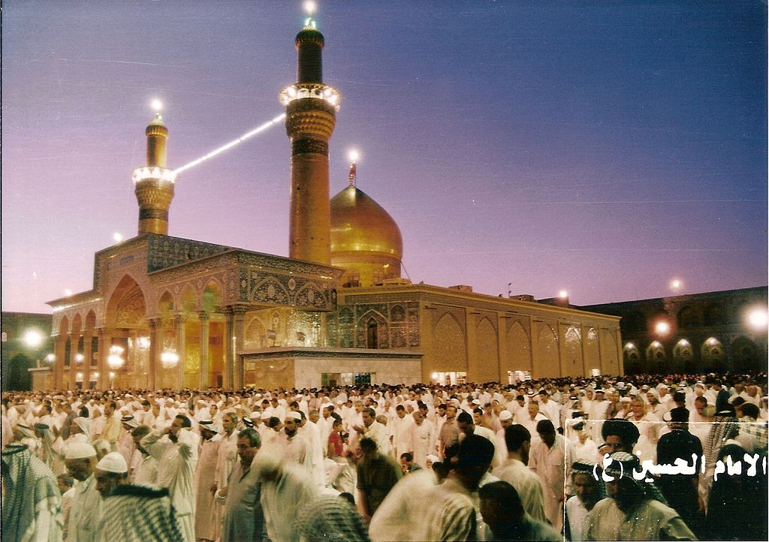
- A good ruler opposes __________ and stands for ________________.
- When talking about others when they aren’t around, say what you would want to hear about _____________.

