Time it Was Stations Worksheet
Directions: Go from station to station and at each station look at the document provided for that station. Spend about 5-10 minutes at each station to analyze the document and answer the questions which correspond to each document.

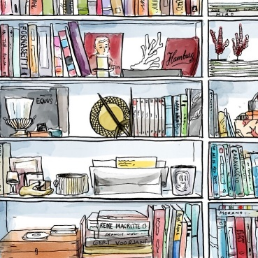
Station 1/4 Activity/Questions
- Examine Document C and analyze how each group is standing in the picture, who seems to be in power here?

___________________________________________________________________________
- How old do these protesters look?

___________________________________________________________________________
- How can you compare this to other stations you’ve looked at?

___________________________________________________________________________

Station 2/4 Activity/Questions
- Examine Document D, and analyze the picture. What is the attitude of each group in the picture?

___________________________________________________________________________
- What do you think is being symbolized by the protesters putting flowers in the soldiers’ guns?

___________________________________________________________________________
- How can we draw comparisons between this picture and other stations?

___________________________________________________________________________

Station 4/4 Activity/Questions
- Examine Document F, what was the conclusion of this report?

___________________________________________________________________________
- What is the commission’s view on violence in the society?

___________________________________________________________________________
- Who created the ghetto?

___________________________________________________________________________
- What parallels can you draw between this report and the other stations?

___________________________________________________________________________

Station 3/4 Activity/Questions
- Examine Document E, who has the power in this picture?

___________________________________________________________________________
- How does this picture show violence against protesters?

___________________________________________________________________________
- How does this document compare to the other stations?

___________________________________________________________________________

